Safe Work Method Statement (SWMS) Part 1
SWMS Scope: This SWMS covers general hazards associated with the stripping and application of sealants on vinyl floor surfaces.
Business Name: A2Z Services |  |  | ABN: 68 195 907 729 |  | SWMS Approved by: Director and General Manager | Date:1/3/21
Business Address:40B Sargent Street, Alice Springs, NT, 0870 |  |  |  |  | Signature:
Business Contact: Area Manager |  |  | Phone #: 1300 229 476 |  | Person/s responsible for ensuring compliance with SWMS: Area Manager
 |  |  |  |  | Person/s responsible for reviewing the SWMS: Safety Team
Relevant workers consulted in the development, approval and communication of this SWMS. |  |  |  | All Persons involved in the task must have this SWMS  communicated to them before work commences.
Name | Signature | Date |  | Daily Tool Box Talks will be undertaken to identify, control and communicate additional site hazards.
 |  |  |  | Work must cease immediately if incident or near miss occurs. SWMS must be amended in consultation with relevant persons.
 |  |  |  | Amendments must be approved by Safety team and communicated to all affected workers before work resumes.
 |  |  |  | SWMS must be made available for inspection or review as required by WHS legislation.
 |  |  |  | Record of SWMS must be kept as required by OHS legislation (until job is complete or for 2 years if involved in a notifiable incident).

Likelihood | Insignificant | Minor | Moderate | Major | Catastrophic | Score | Action | HIERARCHY OF CONTROLS | Most Effective
Almost certain | 3  High | 3  High | 4  Acute | 4 Acute | 4  Acute |  |  | 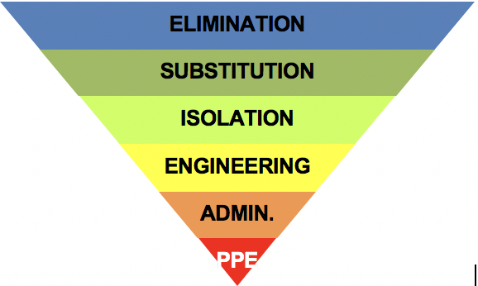
Likely | 2  Moderate | 3  High | 3  High | 4 Acute | 4  Acute | 4A  Acute | DO NOT PROCEED.
Possible | 1  Low | 2 Moderate | 3  High | 4 Acute | 4  Acute | 3H High | Review before commencing work.
Unlikely | 1  Low | 1  Low | 2 Moderate | 3  High | 4  Acute | 2M Moderate | Maintain control measures.
Rare | 1  Low | 1  Low | 2 Moderate | 3  High | 3  High | 1L  Low | Record and monitor. |  | Least Effective

This work activity involves the following “High Risk Construction Work”
☐ Confined Spaces |  |  | ☑ Mobile Plant |  |  |  | ☐ Demolition |  |  |  |  | ☑ Asbestos
☐ Using explosives |  |  | ☑ Diving work |  |  |  | ☐ Artificial extremes of temperature |  |  |  |  | ☐ Tilt up or pre-cast concrete
☐ Pressurised gas distribution mains or piping chemical, fuel or refrigerant lines energised electrical installations or services
☐ Structures or buildings involving structural alterations or repairs that require temporary support to prevent collapse
☐ Involves a risk of a person falling more than 2m, including work on telecommunications towers
☐ Working at depths greater than 1.5 Metres, including tunnels or mines |  |  |  |  |  |  |  | ☐ Work in an area that may have a contaminated or flammable atmosphere
☑ Work carried out adjacent to a road, railway or shipping lane, traffic corridor |  |  |  |  |  |  |  | ☐ In or near water or other liquid that involves risk of drowning
Personal Protective Equipment (PPE): Ensure all PPE meets relevant Australian Standards. Inspect, and replace PPE as needed.
Foot Protection | Hearing Protection | High  Visibility |  | Head Protection | Eye  Protection | Face Protection |  |  | Hand Protection | Protective Clothing | Breathing Protection |  | Sun Protection | fall Arrest | Rings, watches, jewellery that may become entangled in machines must not be worn. Long and loose hair must be tied back.
 |  |  |  |  |  |  |  |  |  |  |  |  | 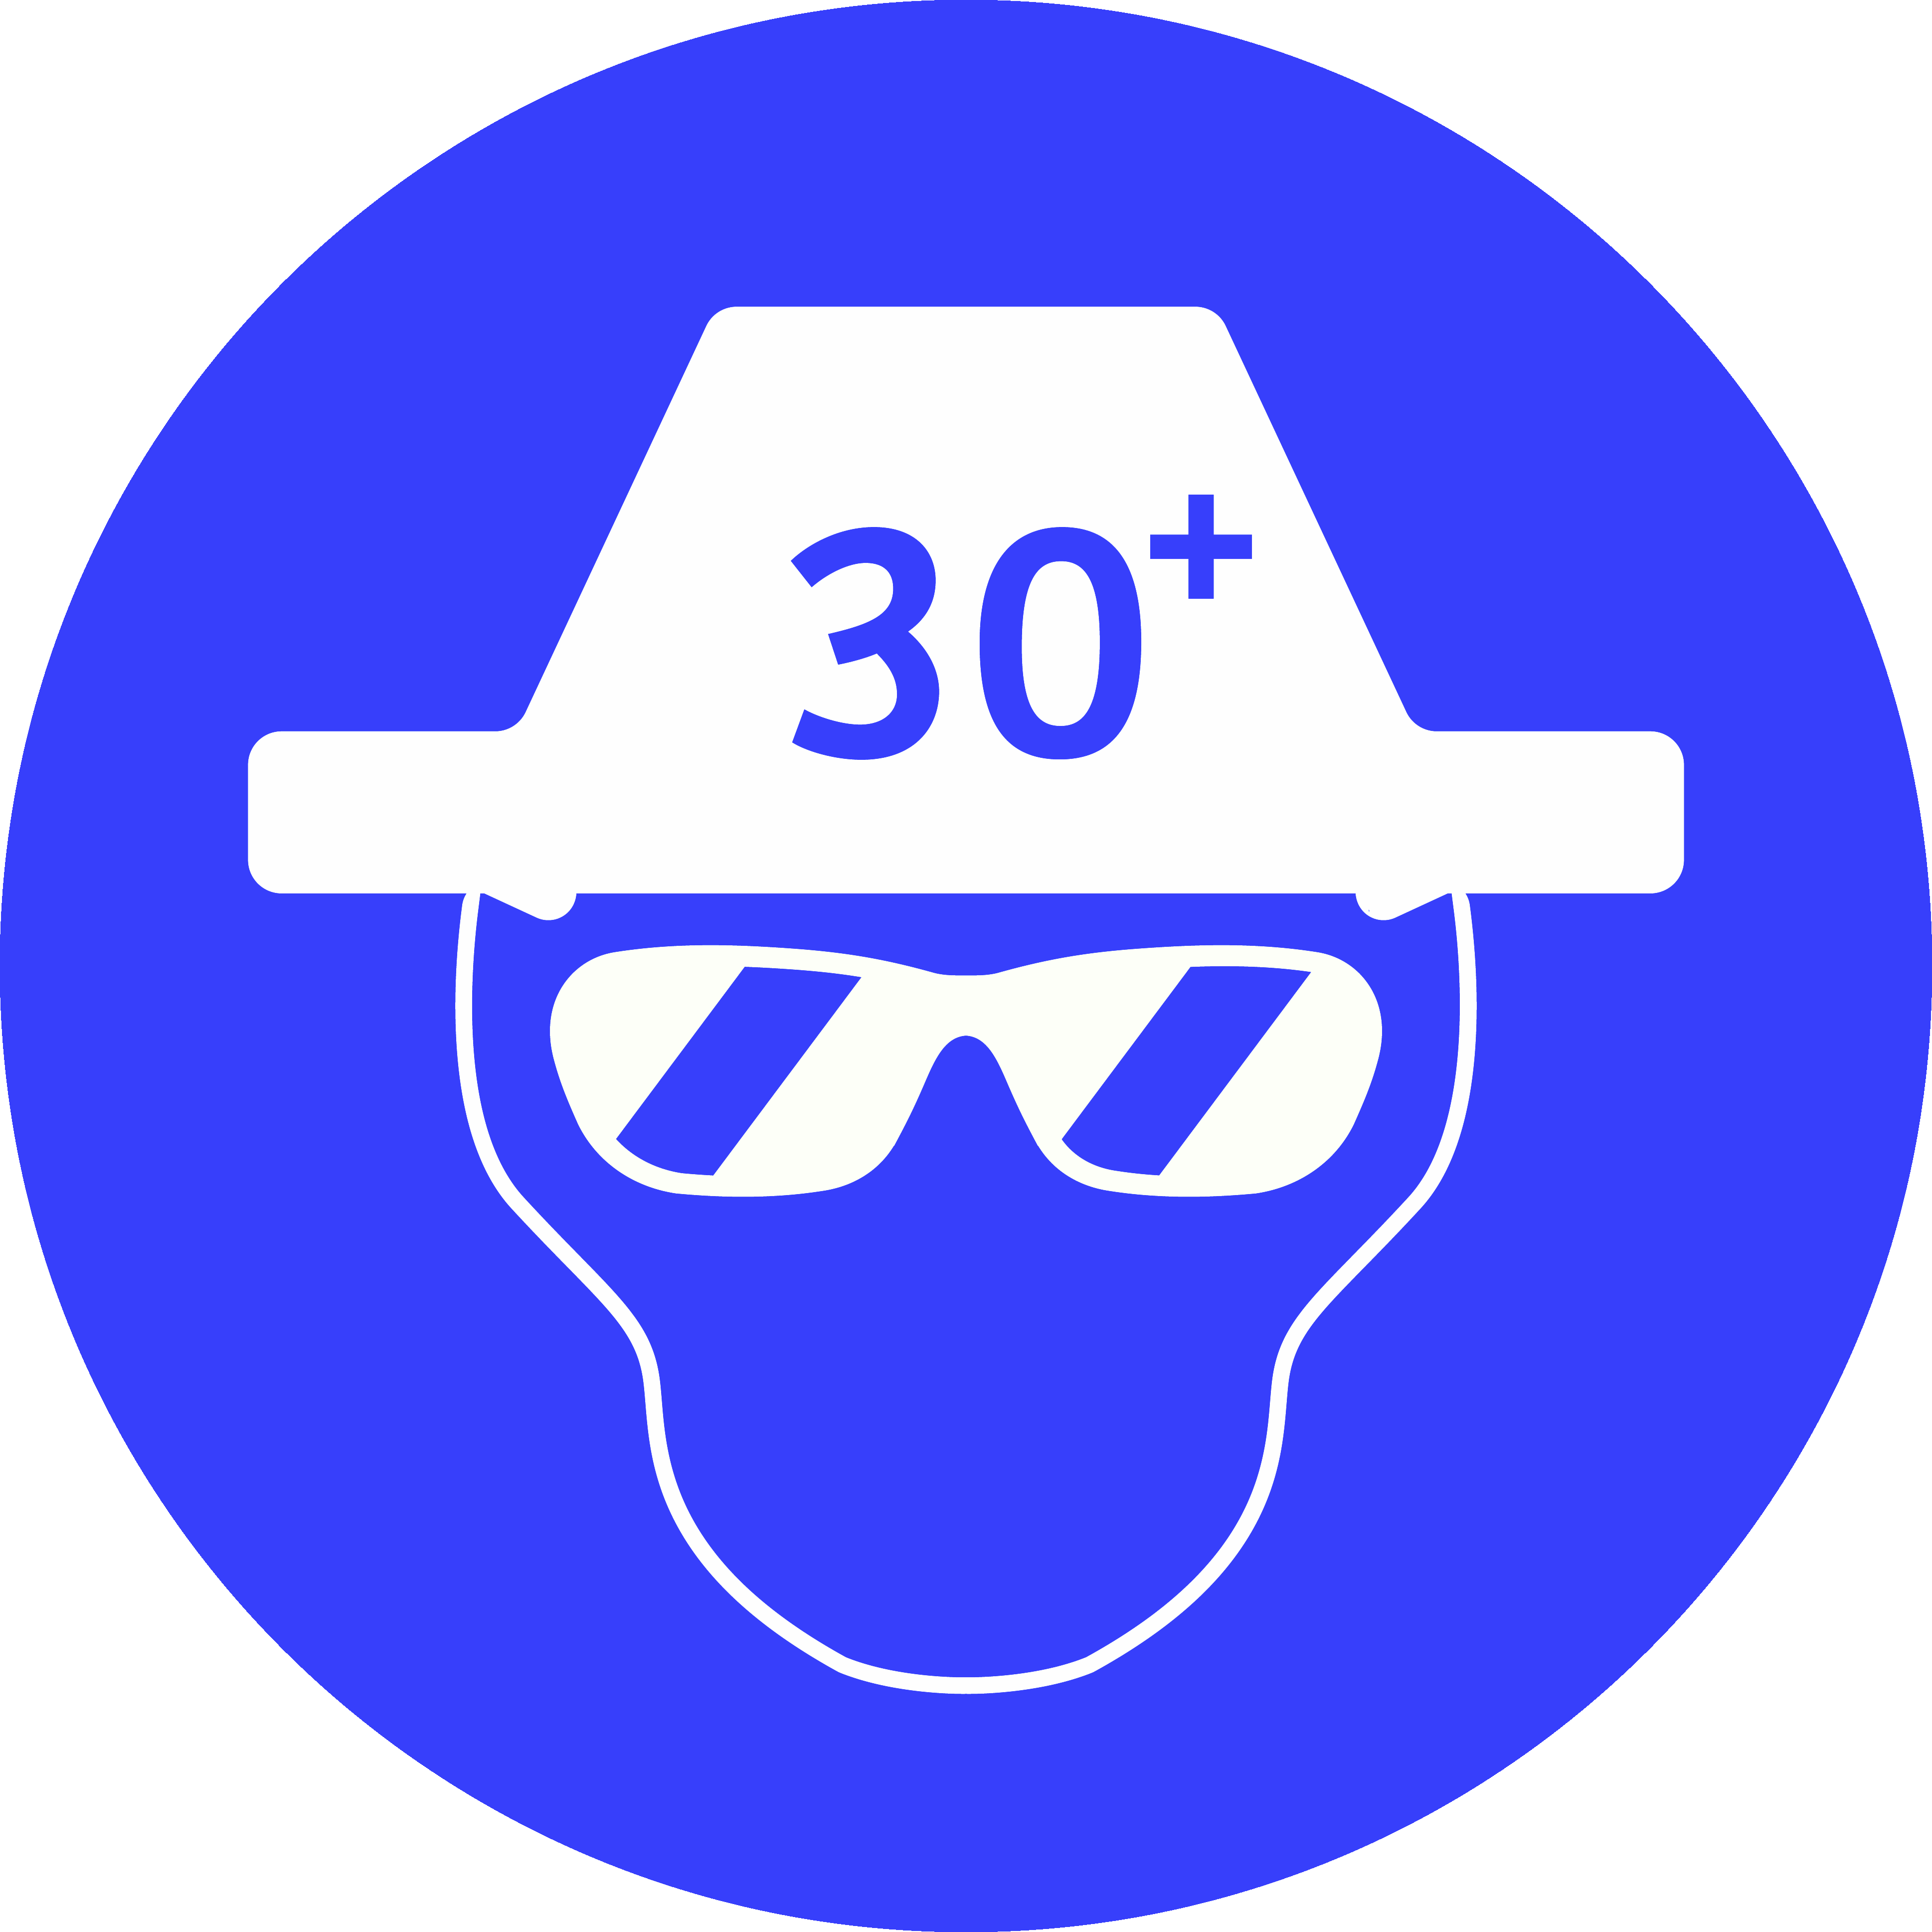 | 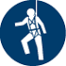
☑ | ☑ | ☐ |  | ☐ | ☑ | ☐ |  |  | ☑ | ☑ | ☑ |  | ☐ | ☐ | ☐
AS 1319-1994 Safety signs for the occupational environment reproduced with permission from SAI Global under licence 1210-c062. Standards may be purchased at http://www.saiglobal.com

Job Step | Potential Hazard/s | IR | Control Measures to Reduce Risk |  | RR | Responsible Person
Inherent Risk-rating (IR) Residual Risk-rating (RR)
- Planning & preparation | Lack of consultation may lead to potential outcomes for personal injury, property damage &/or environmental incident. | 3H | - Liaise with Principal Contractor to establish the following on-site systems and procedures are in place and take note of:  - Health and Safety rules - Induction for all workers – site specific and toolbox meetings - Supervisory arrangements - Communication arrangements - All relevant workers are appraised for required competencies & for any pre-existing medical conditions if working in remote or isolated locations. - PPE required - Site plans – showing no go zones for pedestrians - Traffic Management Plan - Exclusion Zones - Risk Assessments - SWMS and JSA’s - Injury reporting procedures - Hazard reporting procedures. |  | 2M | Organisation
- Training and Capabilities | Untrained/  non-competent worker | 3H | - Ensure all relevant workers are trained and licensed for task  - Ensure all relevant workers have undertaken training and/or received instruction in the use of control measures. Including:  - Instructed on the use of all SWMS  - Reporting procedures for incidents  - Correct use of equipment including selecting, fitting, use, care of and maintenance.  - Competent to undertake the work task.  - Using hazardous chemicals (cement and lime – risk of inhalation and skin contact)  - Hazardous manual handling (risk of injuries caused by repeated movements over sustained periods of time, awkward postures)  - Looking after your knees (bursitis, arthritis).  - Check workers are in fit condition to work i.e. no signs of fatigue, alcohol or drugs |  | 2M | Organisation
- Arrival & assess onsite conditions | Struck by powered mobile plant or roadside traffic | 4A | - Identify and obey all safety related signage (check site entry requirements)  - Ensure all PPE required for site is worn and in good working order, especially High Visibility clothing  - Follow traffic management plan  - Vehicle should be positioned is a safe location, clear of traffic/vehicles/pedestrians during equipment delivery and materials removal (deploy physical barriers, caution signs and equipment, where necessary)  - Do not park illegally  - Alertness at all times. Listen for:  - Reversing alarms/beepers  - Calls from plant operators  - Report to Site Supervisor  - Ensure site-specific induction is undertaken (include location of amenities, first aid facilities, emergency plans and evacuation points, contact persons etc.) |  | 2M | Technician
 | Lack of a clear assessment may lead to personal injury, property damage &/or environmental incident. | 3H | - Assess mobile phone reception  - Work site is exactly as detailed in Terms of Agreement or contract  - Suitable access for all equipment required  - Suitable space for operation of equipment  - Suitable lighting, including night-works  - Environmental conditions acceptable e.g. weather, temperature, atmosphere  - Consult with the person you are carrying out the work for on the potential hazards and risks associated with the task  - If represented by an elected health and safety representative, the representative should be included in any consultation  - Any other persons on site who are affected by the same matter are consulted and co-operative arrangements are made  - Undertake a site and task specific JSA to identify hazards and control risks. |  | 2M
 | Exposure to asbestos | 4A | - Asbestos - If structures were installed or constructed before 31 December 2003. Ensure:  - Obtain a copy of the Asbestos register for the structure  - If no register is present. Ensure:  - No work is undertaken until the existence or absence of asbestos is confirmed  - Use a competent person to determine the existence or absence of asbestos  - Removal of floor tiles:  - Flooring products i.e. Polyvinyl chloride (PVC or vinyl) tiles, black and brown thermoplastic tiles, sheet floor coverings contain chrysotile  - Some underfelt, i.e. hessian underlays for carpets and linoleum contain asbestos  - The adhesives, which were used to bond the floor covering to the surface, could also contain asbestos  - Some hardwearing composite floors (for example, magnesium oxychloride) also contain about 2 per cent of mineral fibres, which could be asbestos  - If there is a presence of asbestos, for this task, ensure there are separate, dedicated SWMS and that all workers/employees have relevant training and licensing. |  | 2M
 | Heat / cold stress | 3H | - Appropriate protective clothing  - Wear hand protection  - Wear non-slip footwear (slippery surfaces)  - Adequate breaks  - Check weather conditions – do not work in extreme conditions, reschedule works | - Cold:  - Encourage workers to have adequate warm drinks  - Access to warm shelter during breaks  - Heat:  - Sun brim on hard hat  - Safety glasses - UV Rated  - Use 30+ sunscreen on exposed skin areas  - Adequate drinking water. | 2M
- Work area set up | Injury to others/public | 3H | - Remove all non-essential persons from area  - Barricade area and place caution signs as needed. |  | 2M | Technician
 | Muscular stress / musculoskeletal disorder (MSD) | 3H | - Ensure:  - Sufficient lighting  - Materials / equipment is as close to work area as possible  - Area, including travel path, is cleared, planks placed and secured where required (ensure trolleys etc. are not pushed through sand/uneven terrain)  - The weight of materials to be lifted is known and displayed  - 2 people lifting, carrying and setting down:  - Work with a person about your height  - Decide in advance which person will direct the move  - Keeping knees bent and back straight, lift and raise the bag together  - Move smoothly together as you carry, keeping the load at the same level  - Unload at the same time, keeping knees bent  - If moving something up or down stairs, the taller person should be at the lower level. |  | 2M
 | Contact with electricity | 3H | - All power tools and leads are Tested and Tagged and are current  - Ensure leads are not damaged – along the entire length of the lead and extension lead  - Do not use electrical equipment in wet or damp areas  - If equipment is damaged, do not use. Take out of service, apply Lock-out/tag-out (LOTO) procedures and inform supervisor immediately. |  | 2M
 | Hazardous chem. / substances | 3H | - Ensure current Material/Safety Data Sheets (M/SDS) are obtained for all hazardous chemicals/substances and accessible on site. |  | 2M
 | Property damage | 3H | - Ensure equipment is not placed in areas where they may be run over, damaged or exposed to water (unless rated for wet environments). Keep power leads up off the ground and out of the way  - Protect existing surfaces, where required, by placing and taping plastic on the surface. |  | 2M
 | Slips, trips & falls | 3H | - The floor or working area is free from rubbish and debris, and that clear access is available  - Wear non-slip, closed-in footwear. |  | 2M
- Stripping & applying sealant & buffing | Exposure to hazardous chemicals /substances:  - Inhalation (breathed in)  - Ingestion (swallowed)  - Absorption (via the skin)  - Asphyxiation (lack of oxygen) | 3H | - Apply stripper and sealant as manufacturers’ recommendations  - Ensure current (issue date with 5 years) Safety Data Sheets (SDS) are obtained for all chemicals and accessible on site:  - Implement all controls  - Workers know where to access the SDS  - Workers know how to read & interpret the SDS  - If SDS is kept on an electronic database, ensure there is a backup system available in the workplace, such as a hard copy in a filing system.  - Read the SDS before using chemicals  - Before mixing any chemicals together, check for compatibility and refer to SDS  - Wear appropriate PPE at all times as recommended on the SDS / label  - All containers (original container or decanted portions) supplied for use at a workplace, must have a label with all required details listed. If a container is not correctly labelled, it must not be used at the workplace  - NEVER decant chemicals into food or beverage containers  - Ensure the correct chemical handling equipment is available and in good condition  - DO NOT:  - Eat or drink when handling chemicals  - Eat or drink without washing hands thoroughly first  - Take food into the work area where chemicals are being used or stored  - Wear contaminated PPE in areas outside the work zone, such as eating areas. |  | 2M | Technician
 | Knee injury - bursitis / arthritis | 3H | - When removing and applying sealant from room perimeter ensure that knee pads are fitted  - Give your legs a break by periodically standing up, stretching and walking around. |  | 2M
 | Contact with moving parts | 3H | - Scrubber:  - Wear PPE as manufacturers recommendations  - Pre-inspect, operate and maintain the scrubber as per manufacturer’s instructions  - Ensure operations manual is available, read and understood  - Ensure equipment rated for atmospheric requirements (water, or explosion-proof for flammable zones)  - Ensure tool suitable for task  - Suited to the material  - Not too powerful for task. E.g.: don’t use larger tool than needed  - Sufficient power for task – excessive force not required |  | 2M
 | Hearing loss | 3H | - Wear hearing protection while using the scrubber  - When choosing Hearing Protection for workers consider that overprotecting by cutting out too much sound can cause difficulties hearing other sounds needed to work safely. Options are earmuffs or earplugs. |  | 2M
 | Repetitive, sustained tasks, forced pushing movements – repetitive strain injury | 3H | - Use the correct hand tool for each stage of the task  - Use long handled squeegee for slurry clean-up  - Ensure the tool handles have:  - Comfortable grip  - No sharp edges  - Are cylindrical and approx. 4cm in diameter  - Allow wrist to remain straight  - Grip length approx. 12cm  - Take regular breaks  - Do not overreach  - Maintain good posture avoiding awkward twisting and side bending  - Practice stretching throughout the shift  - Ensure adequate lighting  - To avoid using repetitive or sustained force ensure scrubber heads are appropriate for each stage of the task. |  | 2M
 | Slips, trips & falls | 3H | - Ensure all slurry is cleaned away before applying new sealant  - Ensure surfaces are cured the required time. |  | 2M
- On completion | Slips, trips, falls | 3H | - Clean up tools and any waste ensuring the site is left in clean and tidy condition  - Clean debris and ensure it is removed from area. |  | 2M | Technician
 | Contact with electricity | 3H | - Disconnect power tool/extension leads from power point before winding up, so that you don’t get a shock if the lead is damaged  - Inspect leads and power equipment for damage  - If safe to do so, remove isolation locks/tags and test appliance for function. |  | 2M
 | Contamination of waterways and water catchment | 3H | - Dispose of empty containers / bags in approved waste containers  - Do not wash out tools or containers where residue can enter waterways or drains:  - Place in small stacks (about a shovel full) and allow to dry for safe removal. Place in bin provided by Builder. |  | 2M
 | Public safety | 3H | - If acceptable, remove barricades, contact supervisor and return as agreed. |  | 2M

Emergency Response - Call 000 immediately.
If work is to be conducted on a construction site (or a site controlled by another Employer / PCBU) follow the site-specific Emergency Management Plan. Ensure:  - Adequate numbers of first aid trained staff are on site when working at heights occurs  - First aiders are trained and competent in managing injuries associated with demolition until emergency services arrive  - All rescue equipment is in good condition, available for use and in close proximity to the work site. |  |  |  |  |  | Ensure workers have access to:  - First aid kit/supplies  - First Aid trained personnel familiar with Resuscitation and emergency response for electric shock  - M/SDS  - Communication devices (check mobile phones will have service in area)  - Suitable fire protection equipment.
Review No. | 1 | 2 | 3 | 4 | 5 |  | 6 | 7 | 8 | 9 | 10
Name:
Initial:
Date:

Plant/Tools/Equipment List for the job (include Type, Make Model, SWL/Capacity)

Relevant Legislation & Codes of Practice | - Download the OHS Legislation and Codes of Practice Reference List 31105-1 from your tax invoice or go to OHS References.  - Copy and paste your State specific references relevant to your scope.
Act & Regulations (paste here) | Codes (paste here)

Safe Work Method Statement (SWMS) Part 2
This SWMS has been developed in consultation and cooperation with employee/workers and relevant Employer/Persons Conducting Business or Undertaking (PCBU). I have read the above SWMS and I understand its contents. I confirm that I have the skills and training, including relevant certification to conduct the task as described. I agree to comply with safety requirements within this SWMS including risk control measures, safe work instructions and PPE described.
Overall Risk Rating after Controls | - 1 Low | - 2 Moderate | - 3 High | - 4 Acute

Workers’ Name | Job Role / Position | Licences, competencies & qualifications (add as applicable) |  |  | Date | Signature
 |  | Type / Description | Class | Number
 |  | Construction Card
 |  | Construction Card
 |  | Construction Card
 |  | Construction Card
 |  | Construction Card
 |  | Construction Card
 |  | Construction Card
 |  | Construction Card
 |  | Construction Card

